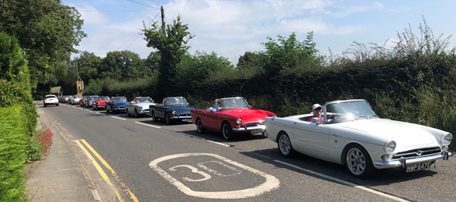
The Sunbeams North West run out – Sunday 25th July 2021.
Following on from last year’s successful trip, I have organised another run for the 25th of July *.
Starting at the Kilton Inn (WA16 0PZ) at 1PM, we will do another tour of the Cheshire countryside followed by a leisurely afternoon of catching up with friends, enjoying the cars and of course food and drink laid on by the Wheatsheaf.
Last year we had 28 Sunbeams so see if we can break the 30 mark this year.
If you wish to come along let me know – jeff.v8tiger@gmail.com
*Because the field we use is privately owned, we have the flexibility to move the day at the last minute if the weather is not looking good. We moved it forward a day last year, so keep the Saturday 24th free just in case.
