2017 STOC Tiger U.S. (California) Tour
Following the success of the Tiger 50 Monte Carlo Tour STOC would now like to offer members the chance to take your own car to California, the birthplace of the Tiger.
The 2 week tour will take place in June 2017 in order to coincide with the 50th anniversary of the end of the cars production run and allow us to join in with the California Club’s Tigers United event. At present the expected date for the start of the tour will be the Tuesday 13th June 2017.
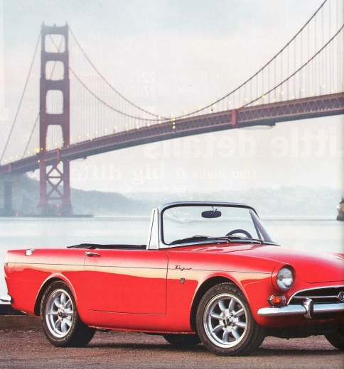
The provisional location for the 2017 Tigers United event, organised by The Sunbeam Tiger Owners Association STOA, is expected to be at McClellan Park, the former McClellan Air Force Base on the outskirts of Sacramento. Further details will be provided as they become available.
It is most likely that cars will be shipped into Los Angeles area. Our cars will be transported from the UK to the west coast of the US most probably by RoRo ferry and return by container. Current advice shows this to be the most cost and time effective method. The transit time is approximately one month each way; cars will be out of the UK from early May until early August. Estimated cost for transit is around £2750 for the return trip, detailed breakdown of shipping, handling and customs costs cannot be determined this far in advance. Cars would ideally arrive in LA a week beforehand and will need to be returned to LA by the 5th July at the latest (actual date to be confirmed).
We will seek to have the cars stored indoors at the port of departure and arrival, though this may involve additional costs.
The Tour
UK flights will depart London Heathrow on the morning of Tuesday 13th June 2017, with the usual arrival time at Los Angeles International mid-afternoon. At present it’s uncertain where the cars will dock in California, either Long Beach (container) or Port Hueneme, Ventura (RoRo). Initial hotel accommodation may be adjusted to suit the port of arrival. Ideally we will stay our first night in the USA on board the former Cunard Blue Riband Liner, Queen Mary which is now a hotel and is moored at Long Beach, or alternatively in Ventura near to Port Hueneme. The intention will be to hold a welcome dinner hosted by the local California Association of Tiger Owners, CAT.
Once we’ve collected our vehicles we will travel north up US Highway 1, the Pacific Coast Highway for an overnight stop at the Madonna Inn at San Luis Obispo, the most ridiculous and amazing motel you’re likely to find anywhere. Next day we will travel a few miles along the PCH stopping at Hearst Castle where you’ll need to allow a few hours to take a tour of the newspaper magnate’s lavish residence, our next night’s accommodation is at The Ragged Point Inn, depending on availability. Continuing north on the PCH we pass through Big Sur, cross the iconic Bixby Bridge and take the toll road along the 17 Mile Drive passing the Pebble Beach Golf Course home to the world famous Pebble Beach Concours held during the Monterey Auto Week each August.

Once we’ve finished our drive we head for our overnight hotel in the Monterey/Carmel area. There should be time while in Monterey to visit Cannery Row, the aquarium and maybe take in a whale watching cruise. We leave Monterey late morning and head towards San Francisco along Monterey Bay, with potential rest stops at Santa Cruz or Half Moon Bay.
Our local Tiger friends have advised that we stay on the outskirts of San Francisco, the intention would be to bus the group into SF for a sightseeing tour. Depending on where we stay, we head away from SF over the Golden Gate Bridge en-route to the wine country at Sonoma or Napa, a detour to the Cobra Experience at Martinez would be available for those interested. The next day we abandon our cars and take a wine tasting tour around a few of the local wineries. The following day we follow a scenic route east towards Sacramento for Tigers United where we can meet up with other Tiger owners. You’ll have the option of taking part in the autocross (auto test to us Brit’s), scenic drive and concours events. We can choose to stay on at Sacramento for our final night or choose a different location for our final dinner together.
The STOC tour reaches its conclusion after the TU event. If you intend heading back to Los Angeles you can choose the direct route via Highway 5 or slower more scenic on 101 (425 miles/7 hours). For those staying on there will be non-official third week tours which you can join, or simply do your own thing. Cars will need to be back at the docks by the 3rd - 5th of July.
Thanks to members of STOA and CAT for their help and support
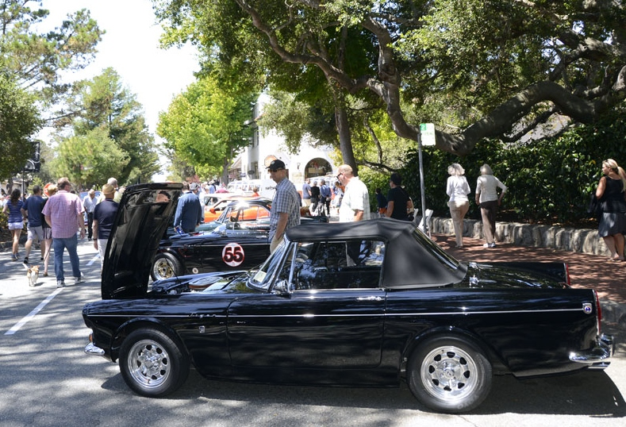
Tigers in Carmel during the Monterey Car week
Provisional itinerary – (based on UK departure)
- Tue 13th June – arrive Los Angeles, Queen Mary, Long Beach or Ventura
- Wed 14th June - Los Angeles, collect cars from port, afternoon sightseeing in LA, or visit the old Shelby factory at Venice Beach/Petersen Museum.
- Thurs 15th June – Drive from LA to San Luis Obispo, hotel Madonna Inn.
- Fri 16th June – Pacific Coast Highway, (visit Hearst Castle). Hotel TBA.
- Sat 17th June – Pacific Coast Highway, (Bixby Bridge, 17 Mile Drive), Monterey. Hotel TBA.
- Sun 18th June - Monterey (whale watching), afternoon drive to San Francisco
- Mon 19th June - San Francisco
- Tue 20th June – San Francisco to Sonoma/Napa, (visit Cobra Experience), Hotel TBA
- Wed 21st June – Sonoma/Napa (winelands coach tour).
- Thurs 22nd June – Sonoma/Napa to Tigers United
- Fri 23rd June – Tigers United (Auto test)
- Sat 24th June – Tigers United ( Scenic Drive/Concours)
- Sun 25th June - Location to be decided (TU venue or alternative location), final night banquet.
The above route/itinerary, timing, locations and attractions are subject to change

Anyone staying on for a third week will be free to choose their own route back to LA. Similar to the Monte Tour, crews may form into smaller groups taking a selection of scenic or challenging routes returning to LA, watch the club forum for details.
Unlike the Monte Tour it is not anticipated that there will be a Tulip style road book, navigation would be by Sat-Nav and a basic route guide. Daily driving distances will be kept as low as possible and we will endeavour to stay multiple nights at several stops on route, making this more of a road trip holiday rather than a full-on “rally”. Hotels will be the highest quality without being overly expensive, for example the Queen Mary in Long Beach is currently $100 a night for a standard room.
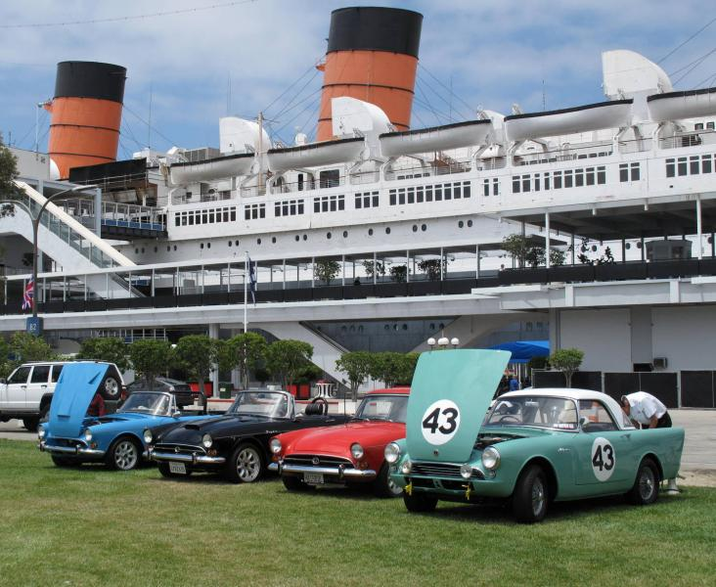
Insurance for the trip will consist of total loss for the transit of the cars while on the high seas and for 2/3 weeks driving in California, Hagertys have indicated a cost of around £1000 per car. Prices will vary on the value of the vehicle
Approximate costs, (based on 2015 prices):
- Transit by container UK to California and return – approx. £2750 per car,
- Insurance transit total loss and driving in US for 2- 3 weeks - £1000 per car.
- Hotel costs per night excluding meals, allow around £150-£200per day per couple.
- Flights Heathrow to Los Angeles - £1400 per couple (economy).
- US Breakdown cover - £100
- Entry to Tigers United, (including some meals) - £300
- STOC (rally plates, shirts etc). - £200
- Arrival night banquet - £150
- (Fuel @ £2.50/ Imperial gallon - £150+ – not included)
The tour has four optional packages:
Package 1 – Shipping, flights, hotels (13 nights) plus all above items. £ 8000.
Package 2 – As package 1 less flights. £6600.
Package 3 – As package 1 less shipping and insurance. £4250.
Package 4 – As package 1 less shipping, flights and insurance. (Non-European cars). £2850.
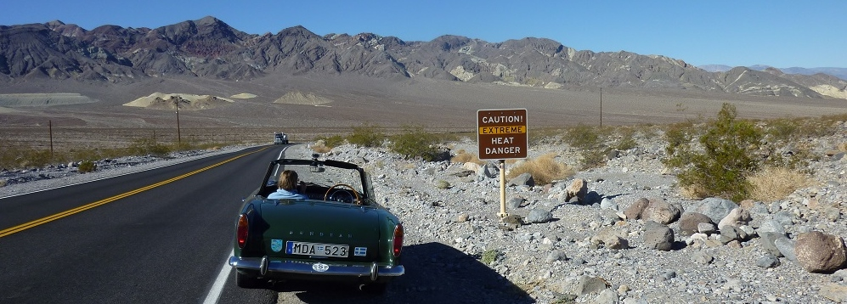
Sunbeam Tiger Owners Club Ltd

Potential places to visit
Los Angeles
Sightseeing tour of Hollywood, Beverly Hills, Santa Monica, Venice Beach.
Photoshoot with Tigers outside the site of the Shelby Factory at Venice Beach.
or visit the stunning looking Petersen Museum car collection.
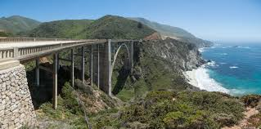
Petersen Automotive Museum
Pacific Coast Highway
Hearst Castle
Big Sur
Bixby Bridge
17 Mile Drive
Monterey/Carmel
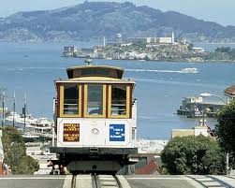

San Francisco
Golden Gate Bridge
Alcatraz
Fisherman’s Wharf
Cable Cars

Booking Form
STOC California Tour – June 2017
Please fill in and return to Lou Lusardi loulusardi@btinternet.com or post to:
L.Lusardi. 25 Vale Reach, Pencoed, Bridgend, South Wales, CF35 6 LG. UK.
Personal & Vehicle Details
Drivers full Name (As on Passport)
Nationality
Address

Email
Telephone
Passengers full Name (as on Passport)
Nationality
Address (If different from above)

Email
Telephone
Car Model (Tiger Mk 1/1A/2, Alpine)
Car Registration
Current insurance valuation
Package number 1,2,3 or 4
Two week tour
Three weeks or longer
I confirm I have read and agree with the terms and conditions
(Please sign and date)

A deposit of £500 will be required to confirm your place on the tour; deposits will be due at time of booking. Payment schedule is detailed in the terms and conditions
Payment is by cheque together with your booking form, please make cheques payable to STOC, or by Bank transfer, see Terms and Conditions for information for how to pay by this method.
Sunbeam Tiger Owners Club Ltd

STOC TIGER U.S. (CALIFORNIA) TOUR. JUNE 2017

PAYMENT SCHEDULE AND TERMS AND CONDITIONS

PAYMENT SCHEDULE
Deposit per person | Deposit  31st Mar 2016 | 2nd Stage Payment  31st July 2016 | 3rd Stage Payment  30th Nov 2016 | Final Payment  31st Mar 2017 | Estimated total
Package 1 – Shipping/Flights & Hotels | £500 | £2500 | £2500 | £2500 Estimated | £8000
Package 2 – Shipping & Hotels | £500 | £2000 | £2000 | £2100  Estimated | £6600
Package 3 - Flights & Hotels | £500 | £1200 | £1200 | £1250 Estimated | £4150
Package 4 – Hotels  (AUS/NZ & US) | £500 | £750 | £750 | £750 Estimated | £2750
Above prices are for guidance and may change if exchange rates/costs increase/decrease.
TERMS AND CONDITIONS
PLACES
Places will be limited with shipping prices based on multiples of 4 for containerised shipping. Spaces on the tour will be allocated on a first come, first served basis with priority assigned to STOC or overseas affiliate club members. Please visit www.sunbeamtiger.co.uk if you are not already a member and wish to join the club.
We can only accept bookings where the STOC 2017 CALIFORNIA BOOKING FORM has been completed in full.

PACKAGES
The packages arranged by STOC will include:
- Shipping of a Sunbeam Tiger or similar sized vehicle from the UK to California, (Options 1&2).
- Flights for 2 adults from the UK to California at Economy rate. Single flights will receive discount offset against single room hotel surcharges, flight upgrades at additional cost. (Options 1&3).
- Shipping transit total loss and US driving insurance, (Options 1&2).
- 13 night’s bed and breakfast hotel accommodation in double or twin rooms. Single occupancy will incur surcharges.
- Breakdown cover in USA. (options 1 & 2)
- 2 Short sleeved tour shirts, 2 tour baseball caps, rally plate and route directions “road book”.
- Arrival banquet & entry to Tigers United Event.

Not included*:
- Transit costs to and from UK ports of departure and arrival.
- Any unforeseen customs duty, port handling fees, storage fees.
- All meals other than breakfast, (where breakfast is provided by the hotel).
- Any drinks purchased at hotels.
- Personal non vehicle holiday insurance
- Fuel and road tolls.
- Entry to places of interest.
- Any mechanical spares or repairs.
- Any parking or speeding fines.

SHIPPING
It will be the responsibility of the owners to transport their vehicles at their own cost to and from the port of departure and arrival. Transit will be by RoRo and/or containerised ship with up to 4 cars per container.
INSURANCE
STOC will arrange total loss transit insurance and driving insurance for the United States (UK/EU vehicles)

DEPOSITS
Deposits are non-refundable with stated exceptions which are:
- If the event is over or under subscribed we will refund your deposit in total.

- Most pricing used to compile the Tour Package are at 2015 rates. You will be notified as up to date 2017 prices become available. In this case the Tour cost may need to be adjusted. Tours costs have been based upon achieving full occupancy. Increased costs by suppliers or failure to achieve full occupancy within a tour may both result in an increase in the published estimated prices. In the event of an increase in price of the Tour exceeding 20% prior to 31st July 2016, we will refund your deposit in full, if you so wish.
BOOKING FORMS AND PAYMENT
Payment may be made by cheque (UK Members) made payable to “STOC”, or Bank Transfer; STOC @ Barclays, Sort Code 20-41-12, account number 00820814, IBAN number GB81 BARC 2041 1200 8208 14.
Sorry we cannot accept payments by PayPal.

Cheques together with the completed STOC U.S. Tour Booking Form should be forwarded direct to Lou Lusardi loulusardi@btinternet.com or post to: L.Lusardi. 25 Vale Reach, Pencoed, Bridgend, South Wales, CF35 6LG. UK.
You may opt to complete your Booking Form online. A downloadable entry form can be found on the STOC website www.sunbeamtiger.co.uk. The completed form should then be emailed to loulusardi@btinternet.com
CANCELATION
If you cancel before 31st July 2016 we will refund your deposit less a £20 administration fee. Cancellation before 30th Nov 2016 = loss of deposit. Cancellation after 30th Nov 2016 and before 31st March 2017 = 50% of all payments made. Cancellation after 31st March 2017 will incur 100% loss of all payments.
Change of names and transfers will not be possible once any flights have been booked and shipping space allocated.
COMMUNICATION
You will receive confirmation of your booking via email by 30th March 2016.
There will be regular updates via the STOC website or Forum (www.sunbeamtiger.co.uk) which will inform you about any changes to programmes or their cost. We will also compile guest lists for the Tour which you will also find on our website.
You will receive notification by 31st December 2016 of the final payment due via email and within this email we will confirm final costs of the Tour. Please contact event organiser, Lou Lusardi with any event queries loulusardi@btinternet.com
Details correct as of 30th November 2015.
L.Lusardi STOC
Organised by The Sunbeam Tiger Owners Club.

